Personal Portfolio

Release 1

**About Music School Page**

### About%20Page/Screenshots/Landing%20View.png

### About Page

Location: pages/about/about.php

The about page was developed to provide any visitor with information about the music school. The page is a static page that was developed to provide a sense of completeness to the solution.

### ../../../../../Desktop/Screen%20Shot%202016-10-21%20at%204.04

### Navigation Banner Image Logic

Location: inc/nav.php

To improve the user experience several pages show different banners. This was developed in conjunction with the About page to give the user a clearer feeling of the page that they are on.

**Contact Page**

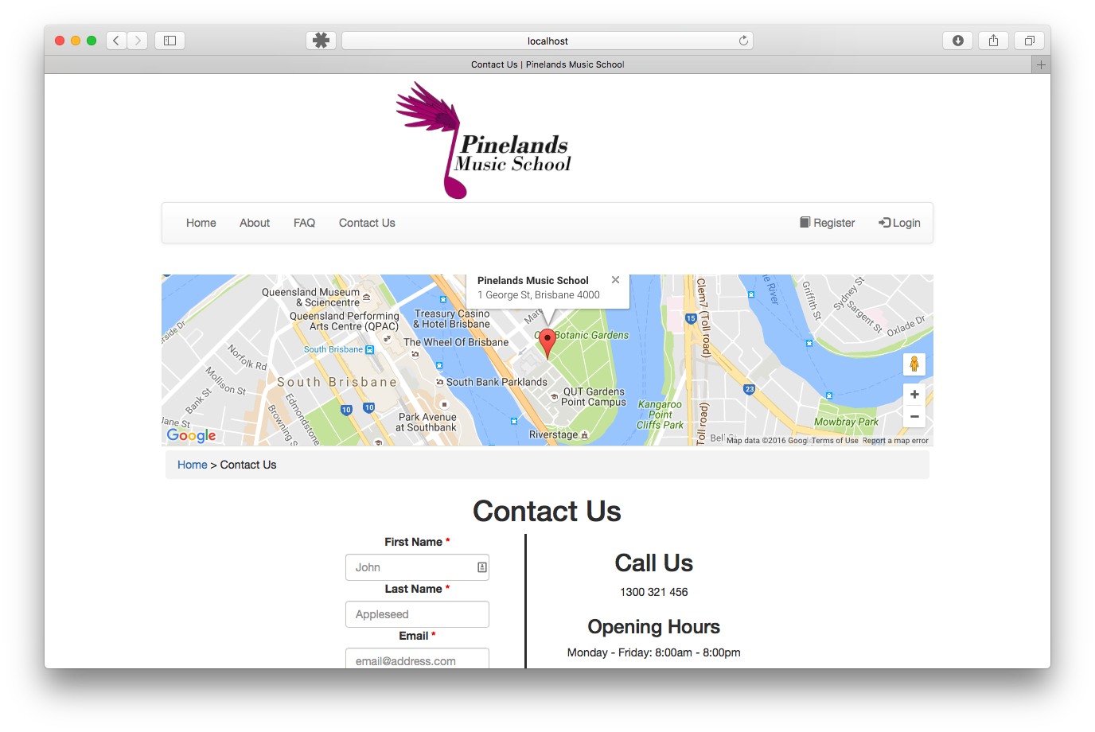

### Contact Page

Location: pages/contact/contact.php

This page was created to help visitors of the website to find a way to contact the Music School and discover the location of the school. It features a contact form that sends the owner an e-mail with the information the user entered as well as a Google Map displayed using Google’s Maps API.

Contact Form Processing

Location: inc/contact_form_processing.php

The contact form processing sends a formatted e-mail to the e-mail address specified in the code of this file.

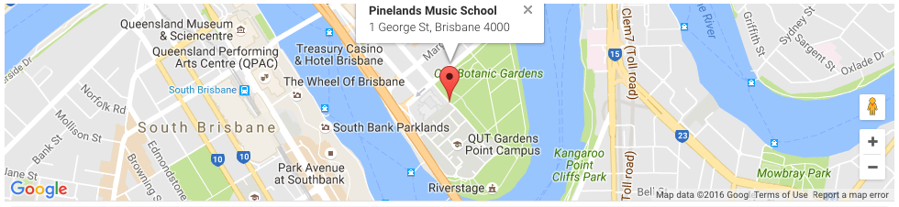

### Navigation Banner Logic

Location: inc/nav.php

The banner image is replaced by the Google Maps API that drops a pin at the location of the Pinelands Music School. The map has been modified to center to the pin and not allow the user to move the location.

**Created Facebook Group**

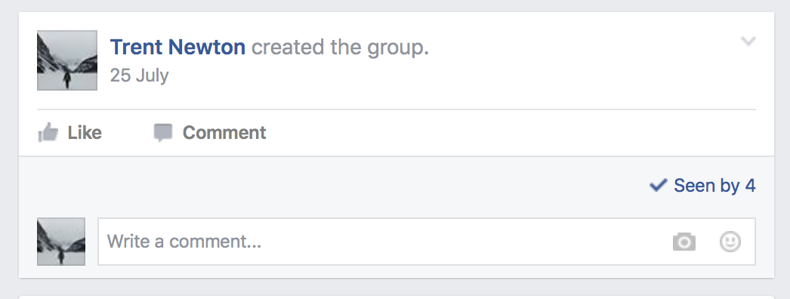

I created the Facebook Group to allow our team to communicate and share information when we aren’t together in a group. This was used regularly throughout the semester to notify all member about upcoming tasks.

**Frequently Asked Questions Pages**

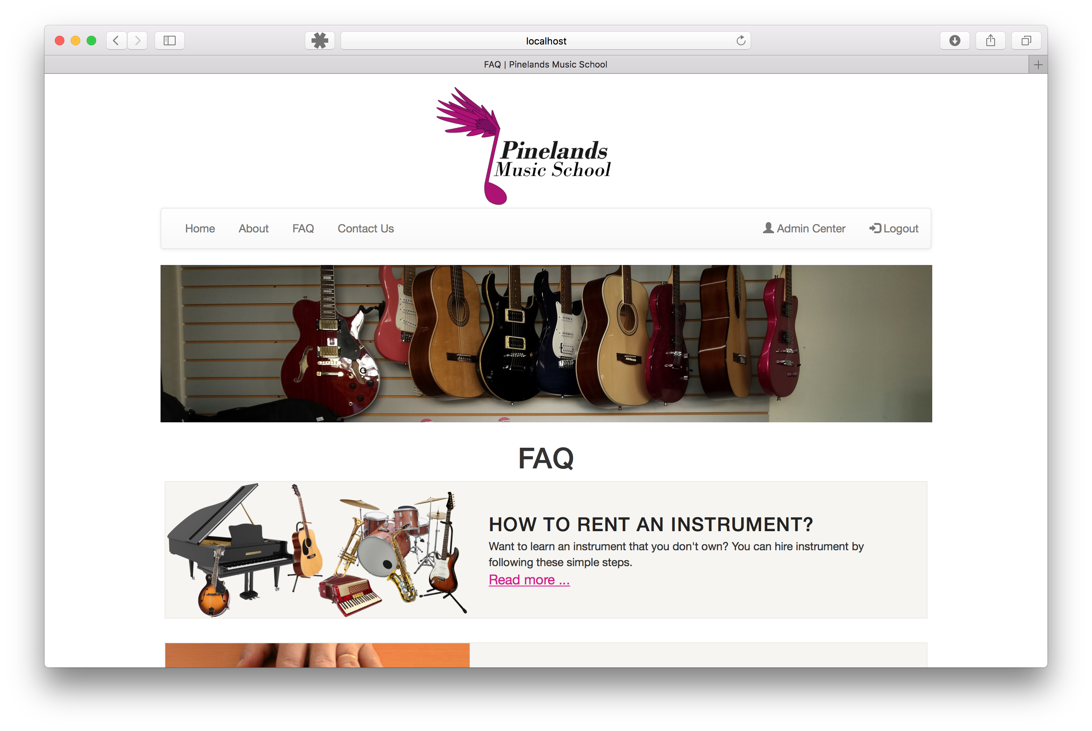

### FAQ Home Page

Location: pages/faq/faq.php

This page was developed to allow potential students or teachers to learn more about the school and have questions answered without having to contact the school. Each FAQ is listed with with it’s image, a title and tester excerpt. This page helps make the website functional and informative.

### Frequently%20Asked%20Questions/Screenshots/Detailed%20FAQ.png

### FAQ Home Page

Location: pages/faq/hire-an-instrument.php

Each individual FAQ page shows the title, description and image so that the potential student or teacher can read in detail about that particular frequently asked question.

**Initial Database Design**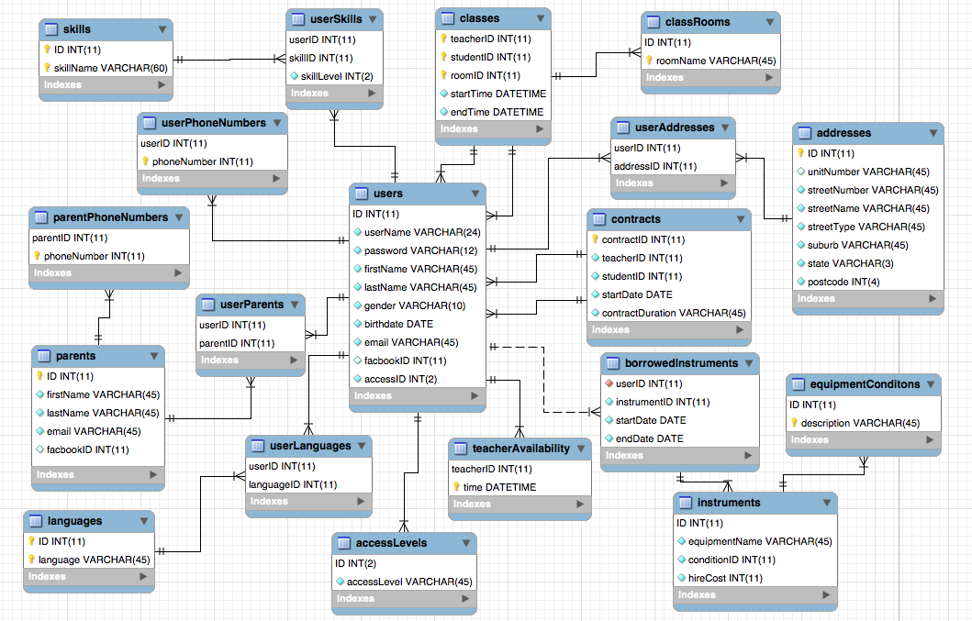

### Initial Database Design Scheme

In the first few days of the sprint I began to design and conceptualize the database that would store the websites data. A well designed database is critical for insuring data is stored efficiently, is retrievable easily and it avoids growing pains when the client’s requirements change and in turn changes the structure of the data that is stored.

The initial design was used very briefly before being replaced with a simpler database with less connector tables however the final form of the database still maintains majority of the table structure and features of this scheme and database that was made in the first week.

**Our Teachers**

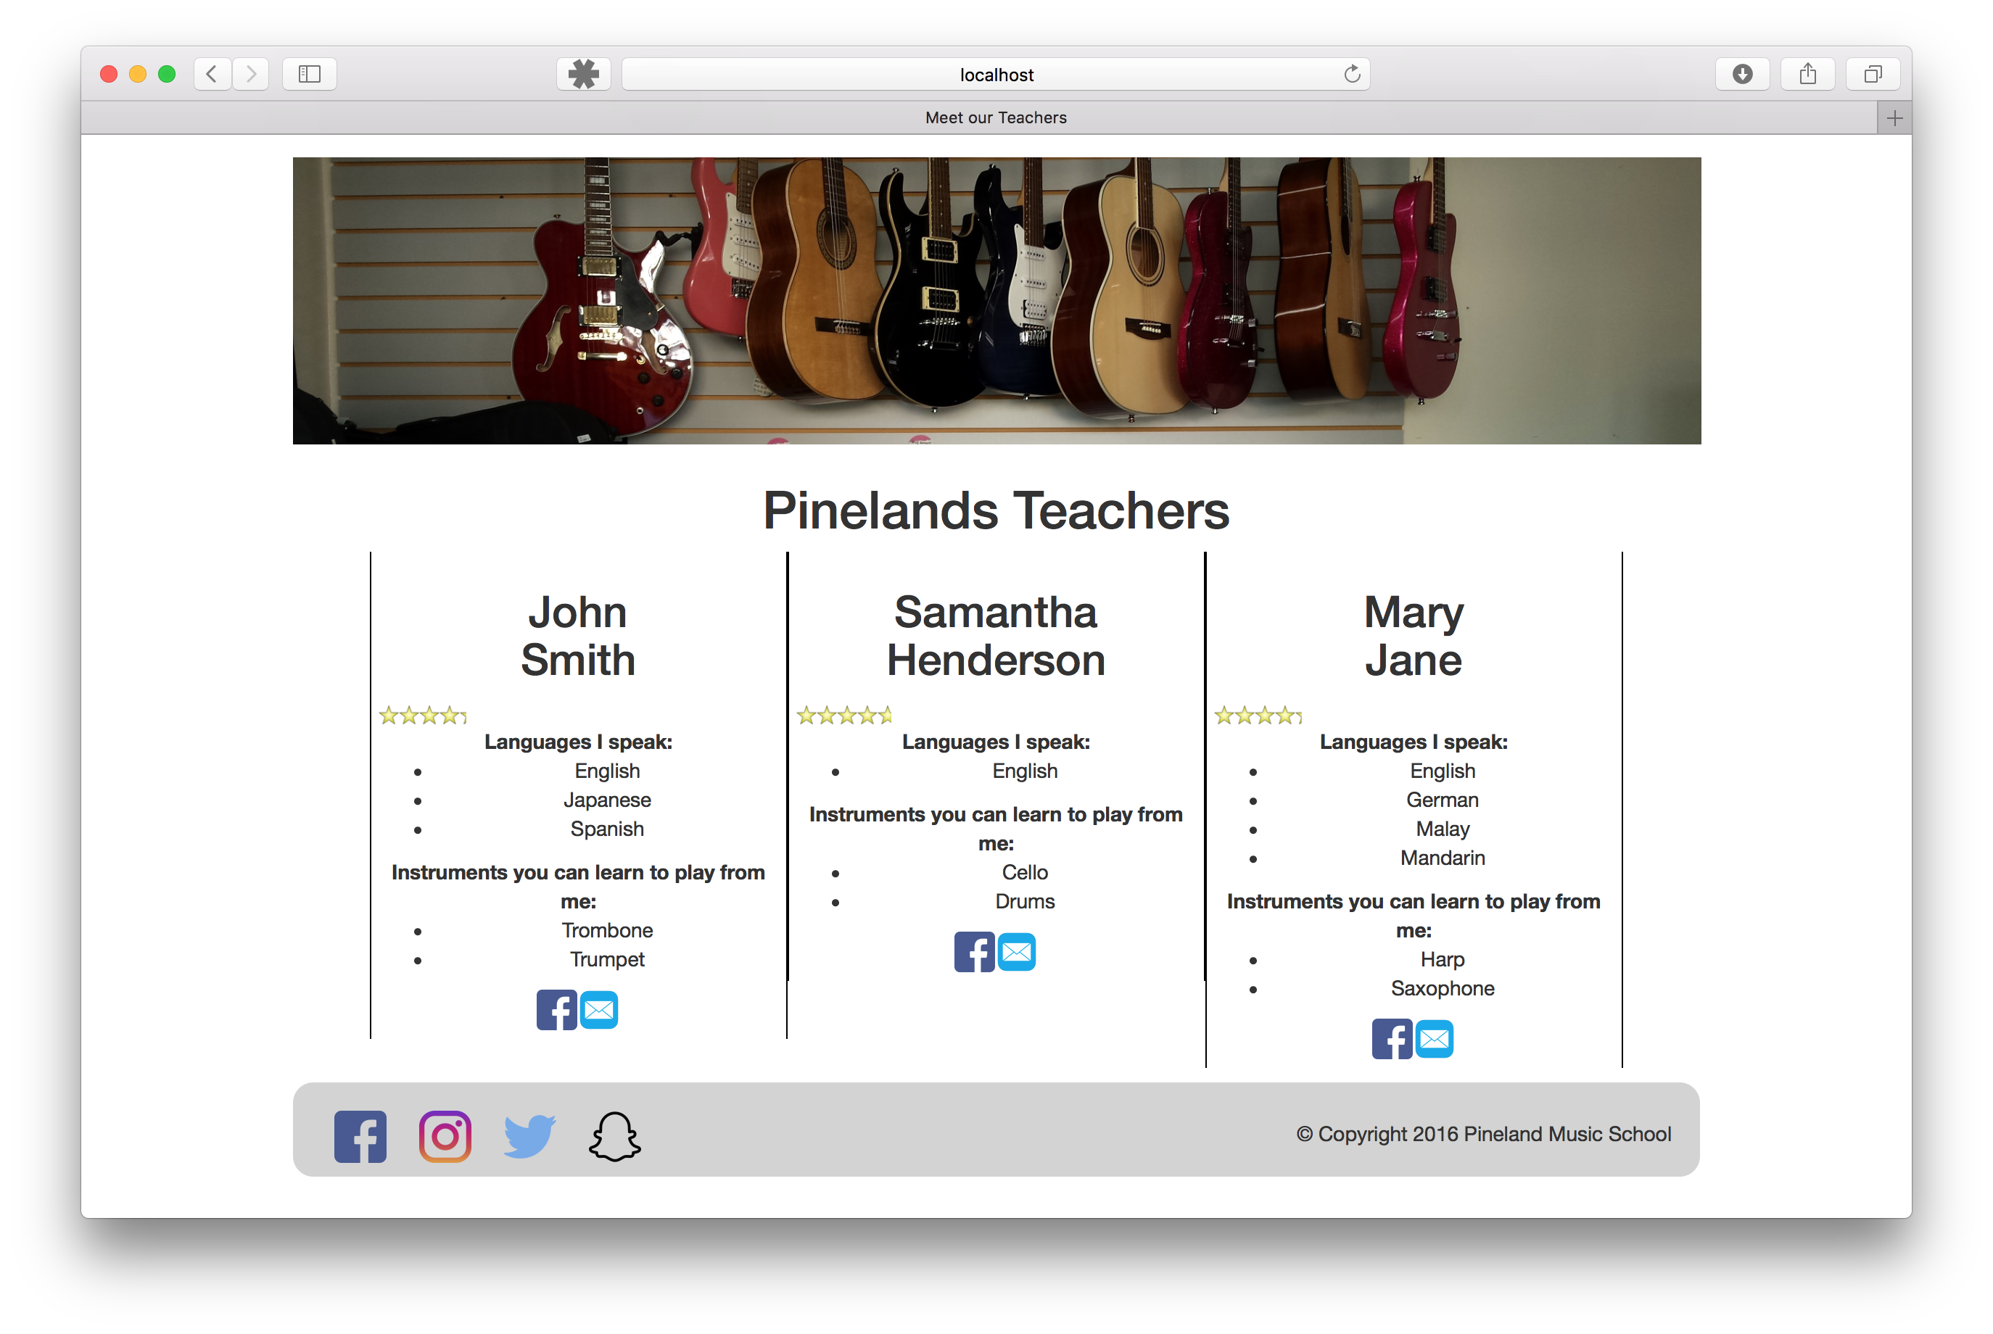

### Our Teachers Page

The Our Teachers page used an SQL query to retrieve all the teachers that worked at the school and displayed them on a single page. Each teacher’s language and instrument skills are listed.

In addition, each teacher can be contact via Facebook or e-mail using the icons at the bottom. The e-mail link is a simple mailto: HTML solution while the Facebook link uses the required FacebookID that all teachers must provide to develop a link.

Below the teachers name a 5-star rating system is displayed. This rating is controlled by the reviews each teacher has received from past contracts with current or past students that are of the status public. All the reviews of that teacher are added together then divided by 5. Using jQuery I was able to take an image of 5 stars and change the visible length. I have been able to get precision of 1 decimal place and this code is reused in multiple places through the website. This page allowed potential students to see the quality of the teachers and what skills they had to offer to teach them.